NAF Principles of Information Technology

Lesson 12

Operating Systems

Student Resources

|  |  |
| --- | --- |
| Resource | Description |
| Student Resource 12.1 | Reading: Overview of Operating Systems |
| Student Resource 12.2 | Reading: Comparing Operating Systems—Microsoft Windows, Mac OS X, and Linux |
| Student Resource 12.3 | Venn Diagram: Operating Systems |
| Student Resource 12.4a  Student Resource 12.4b  Student Resource 12.4c | Reading: Managing Files in Windows 7  Reading: Managing Files in Windows 8.1  Reading: Managing Files in Windows 10 |
| Student Resource 12.5 | Project Planner Page 7: Planning a Dream Personal Technology System |
| Student Resource 12.6 | Assignment: Finalizing Your Project Planning Report |

Student Resource 12.1

Reading: Overview of Operating Systems

An **operating system** (OS) is a type of software. It is the first user-accessible software installed onto a computer, usually installed by the manufacturer of the computer. The operating system is also the first program loaded into memory. This happens every time you boot or reboot your computer. Every desktop or laptop computer has an operating system; without an OS, a desktop or laptop is useless. An operating system organizes and controls a computer’s hardware and software to make the computer easy for a person to use.

Remember, **computer** refers to more than a desktop or laptop computer. These days, almost anything we turn on has some kind of computer. Not all products with computers have operating systems. Simple devices, such as microwaves, do not require operating systems; their computers run on low-level programs installed directly onto chips. However, more and more electronic devices, from MP3 players to cell phones to video game consoles and smart TVs, all contain computers running operating systems, many of which are specifically developed for a particular type of device. Hundreds of operating systems are available for special-purpose computers, including operating systems that control mainframes, robots, manufacturing equipment, and scientific instruments.

As an introduction to operating systems, let’s begin by discussing operating systems as they relate to desktop or laptop computers.

Operating Systems Tell Computers How to Work

When you turn a computer on, the first thing accessed is a firmware interface called the **BIOS** (basic input/output system). In simple terms, the BIOS configures your CPU, memory, hard drives, and peripheral ports (USB, FireWire, etc.) using settings that have either been preset by the manufacturer or configured by the computer’s operator. After the BIOS finishes, it accesses whatever has been defined as the computer’s system drive (usually C:), searches for the programs necessary to start up the operating system, and executes them. To locate and load the OS, a special program called the bootloader is now run. At this point, the computer functions are turned over to the OS. This entire process is known as the boot process, or bootstrapping. The computer must boot when it is first turned on, and you can also reboot your computer, which combines shutting down the operating system and then starting the boot process over. (Rebooting is sometimes called a warm boot, as opposed to a cold boot, which is what occurs when the computer has been off.)

Typical Desktop/Laptop OS Functions

Different operating systems offer different options and variations, but all have the following components in common:

* **Processor management:** We use the term **multitasking** to describe modern operating systems. This means that while a CPU can run only one program at any given moment, several programs can be running. The operating system causes the processor to switch between the programs very rapidly (several millionths of a second). If there are 10 programs running, the initial program is resumed by the OS in far less than a millisecond (thousandth of a second). Older operating systems did not have this capability of switching off; they were known as single-tasking systems. With multicore CPUs, modern computers can literally run multiple programs simultaneously, one per core, but each core is still switching off rapidly between the programs it is tasked with running. So each core is multitasking while the CPU is **multiprocessing**, or **parallel processing**. Parallel processing can significantly improve the performance of a computer.
* **Memory storage management:** The OS makes sure each task has enough memory to do what it needs to do. It also makes sure it does not run into the memory space of another task. The OS sets memory boundaries while ensuring different types of memory are used in the most efficient manner. To ensure that multiple programs can fit into memory, an OS uses an approach called **virtual memory***,* where only parts of each program are loaded into memory while the rest are stored on the hard disk in a reserved space called the swap space. The OS is in charge of swapping: moving new parts of the program into memory, and discarding what is no longer needed.
* **Device management:** The OS manages the traffic of information between a computer and attached devices, such as a printer, an MP3 player, or a thumb drive. It regulates the transfer of data from the device to the computer and from the computer back to the device. This function is especially important when a number of processes are running and taking up processor time. If the CPU is being overtaxed, the OS may continue taking input from the device but hold the data in a “buffer.” Then, once the CPU is freed up, the OS releases the data to continue its journey through the CPU.
* **Application interface:** Operating systems provide a stable, consistent way for applications to be loaded on and removed from the computer and for applications to work when the user is ready to access them. An application program interface (API) allows a software developer to write an application on one computer and have a high level of confidence that it will run on another computer with the same OS, even if variables such as amount of memory or quantity of storage are different on the two machines. For example, today’s operating systems work with thousands of different printers and other peripherals because the designers of these tools use the same set of specific guidelines (the API) defined by the OS.
* **Disk access and file systems:** A computer’s OS allows a user to access files stored on the computer’s hard disk or external drives. The specific way files are stored on a disk is called the **file system**. The file system allows users to name and organize files in a hierarchy of folders (also called directories).
* **Device drivers:** The OS does not know how to talk directly to any of the peripheral devices that you have connected to your computer. For this, it relies on a series of programs called device drivers, one per device. Before you can use a specific device with your computer, the proper device driver must be loaded and installed. Operating systems today may come with the most popular drivers already installed, while hundreds of others can be loaded and installed from the installation disc or from the Internet.
* **Protection and security:** Two related tasks utilize user accounts and permissions so that one user cannot misuse the resources of the computer, including files owned by another user. **Protection** applies to a single computer. **Security** is the extension of protection across computer networks so that users who have an account can access their resources remotely (across a network).

|  |  |
| --- | --- |
| File system hierarchy of folders |  |

* **Other functions:** Most operating systems also determine the way computers communicate with each other via networks as well as the security controlling who can access these networks and when.

The OS and the User: Graphical User Interface (GUI)

The user interacts with the OS via a series of images and words, which represent different tasks. This is called the **graphical user interface** (GUI—pronounced “gooey”). Although not technically part of the OS, the GUI allows users to easily organize and find their way around the computer. Most GUIs use a desktop metaphor, simulating on the monitor images, or *icons*, of items people find on their physical desks: folders, pieces of paper, and so on.

The following image shows the desktop metaphor and file system of the Mac OS X GUI:

|  |
| --- |
| mac_screenshot2 |

A GUI also may allow the user to customize, through a number of options or preferences, what his or her virtual desktop looks like and how it works. Here are some examples:

* The size, color, and text size of objects
* Background/screensaver images
* How and where items are organized (on the desktop vs. in a directory or subfolder)
* The applications that should be automatically launched at start-up
* Speaker audio and monitor brightness level

In addition, the GUI provides easy access to system maintenance tools. These tools are used to do the following:

* Back up data
* Identify and remove system bugs
* Monitor and diagnose problems related to use of the CPU, memory, disk, and other resources
* Review file system operations and optimize disk space

The following image shows a portion of the Control Panel menu for the Windows 8.1 GUI:

|  |
| --- |
|  |

Common Desktop/Laptop Computer Operating Systems

Early operating systems were single-user and single-tasking. This means that only a single user could use the computer at a time, and the user was only able to run a single program at a time. Operating systems have become more capable, and multitasking has been added. For example, your computer allows you to work on a school report while downloading a PDF from the Internet and printing the text of an email. Although computers today are generally used by a single user at a time, they are also capable of handling multiple users, as multiuser systems.

The most common desktop OSs are as follows:

* **Microsoft Windows:** Microsoft Windows is the name of several families of software operating systems by Microsoft. Microsoft Windows dominates the world’s personal computer market and is loaded on more than 85% of personal computers worldwide. Much of the day-to-day work in the IT field requires the use of Windows, even if other operating systems are also used. Computers that run Windows are made by a variety of computer hardware manufacturers, including HP, IBM, Dell, and others. Windows 7 is currently the most dominant version of the Windows operating system in use today. Windows 8.1 was released in late 2013 but has had trouble gaining wide acceptance because of the radical redesign of its user interface. A popular option for people who purchase Windows 8 is to disable many of Windows 8’s newer features and download free utilities to make the user interface look more like the Windows 7 and earlier desktops. The Windows 8.1 release addresses some of the shortcomings and unfamiliarity issues that Windows 8 introduced. The goal of Windows 8 is to provide a common interface between desktops, laptops, tablets, and smartphones that use a Microsoft OS.

In July 2015, Microsoft released Windows 10. Microsoft’s goal: to create compatible architecture for Windows PCs, Windows phones, and Xbox One. This makes it easier for developers to create new apps that will work across all Microsoft platforms; it also makes it easier for users to have Windows devices that work seamlessly together.

* **Unix-based OSs:** Unix-based operating systems (including System V, BSD, and Linux) are an alternative but important desktop/laptop OS option. Most of these are free and run on a wide variety of computers. Although Unix-based OSs run on fewer than 1% of personal computing desktops, many are found on workstations in creative, academic, and engineering environments and are used heavily for servers in business. However, the Android variant of the Linux OS has quickly come to dominate mobile devices such as tablets and smartphones, and it currently runs over 48% of tablets and over 80% of all smartphones.
* **Apple Macintosh:** Mac OS X is the name of a family of software operating systems by Apple Computer. OS X is loaded on computers made by Apple and does not work on any other computer hardware. The current version of OS X is 10.11 (“ten point eleven”), also known as El Capitan (released in September 2015).

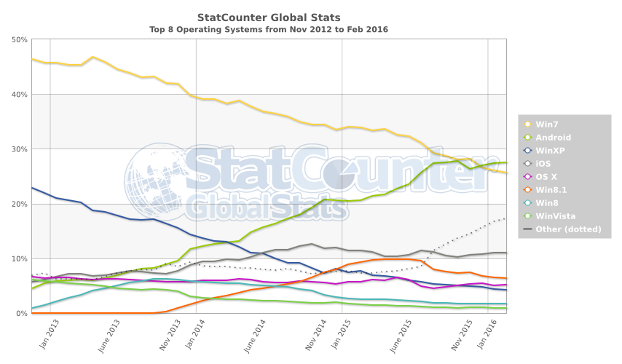.

The graph above shows the usage of common operating systems **worldwide** from November 2012 to February 2016. You can easily see which operating systems are becoming more popular, which are declining, and which are stable. iOS, which is a scaled-down and highly specialized version of OS X, is Apple’s operating system for its iPhone, iPad, and Touch mobile devices. Windows XP is no longer supported by Microsoft as of April 2014.

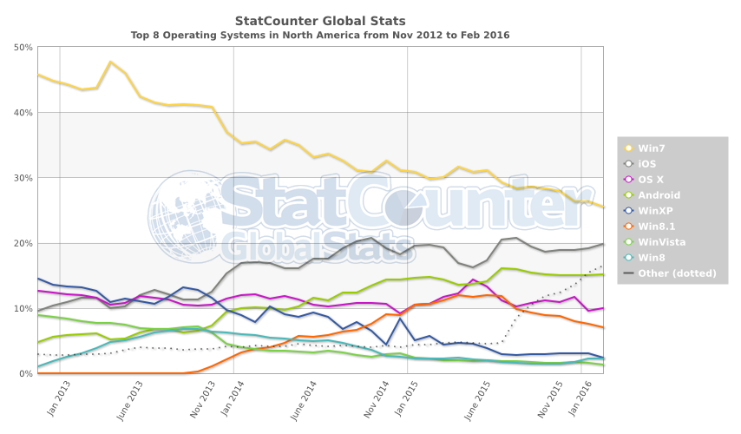

This second graph shows the usage of common operating systems in **North America** from November 2012 to February 2016. Which operating systems are more popular in North America than they are worldwide? Why do you think this is true? To find operating system statistics that are more up-to-date or that show different combinations and locations, go to<http://gs.statcounter.com>.

Conclusion

Every computer requires an operating system. An OS is a piece of software that does the following to tell a computer how to work:

* Controls how the computer processes information
* Organizes information
* Ensures that users can work with a variety of applications
* Provides a GUI so that people can interact effectively with the computer

It is a good idea to familiarize yourself with as many operating systems as possible. When you have the opportunity to use a different operating system, be sure to try it out. If you know one operating system well, learning a second or third one is much easier.

Student Resource 12.2

Reading: Comparing Operating Systems—  
Microsoft Windows, Mac OS X, and Linux

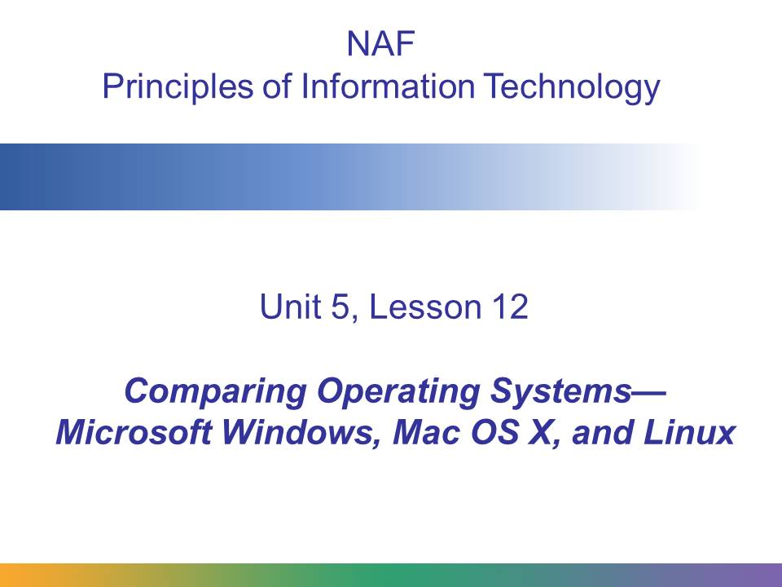

This presentation explains how important the operating system of your computer is. It shows how different operating systems perform various tasks.

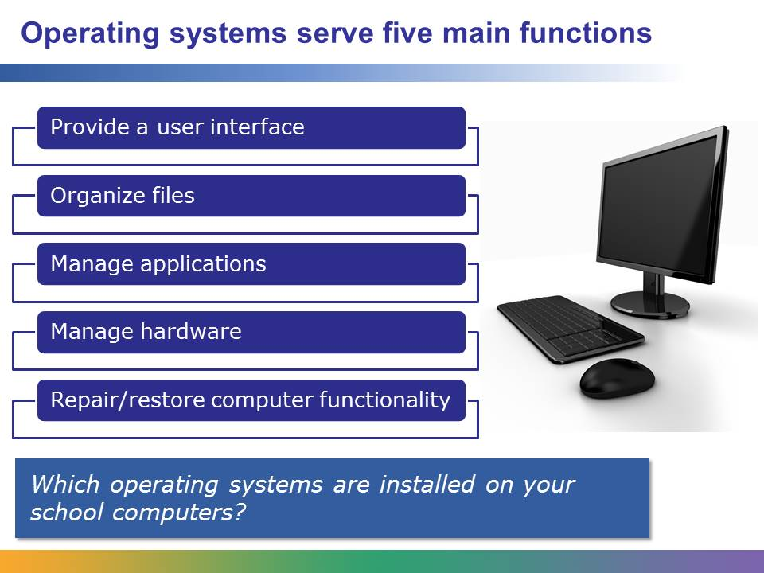

Every computer needs an operating system to run it. Without an OS, a computer is useless. An operating system organizes and controls a computer’s hardware and software.

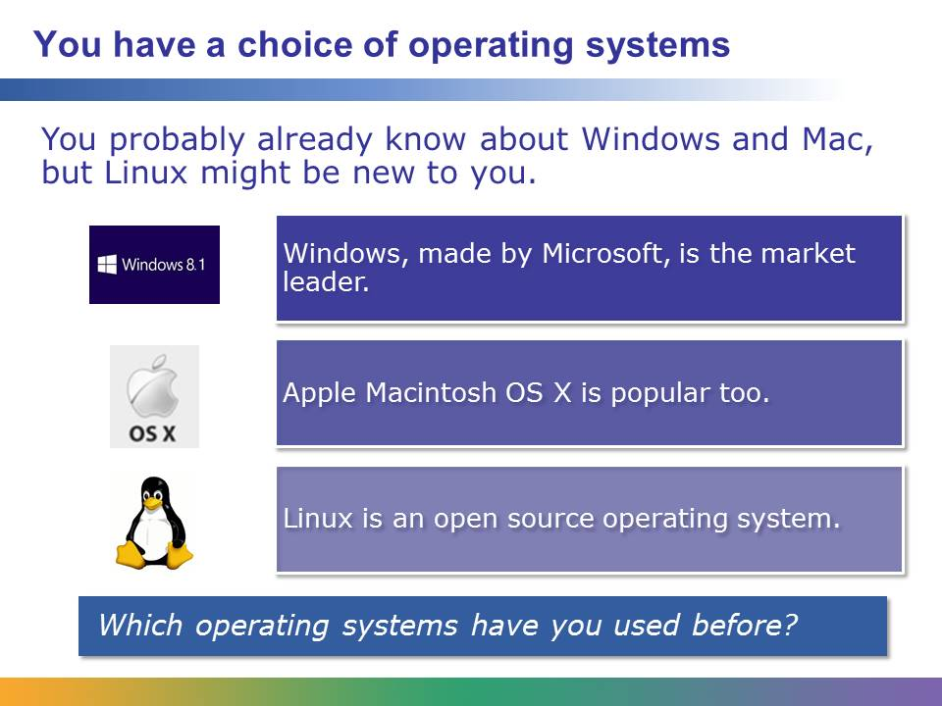

Linux is an open source OS, which means that the code is freely available for anybody to review and is mainly written by volunteers. Many companies and organizations have their own version of the Linux OS, such as Ubuntu, SUSE, Red Hat, HP, Dell, IBM, Novell, and Sun Microsystems. The different versions of Linux are called *distributions*.

Linux is similar in appearance to an older operating system called Unix. Although the two look similar, they differ in implementation, and many of the Unix dialects are not open source.

In this presentation, we focus on Windows 8.1, Mac OS X, and the Red Hat and Ubuntu versions of Linux.

The images on this slide are included under fair-use guidelines of Title 17, US Code. Copyrights and trademarks belong to their respective owners.

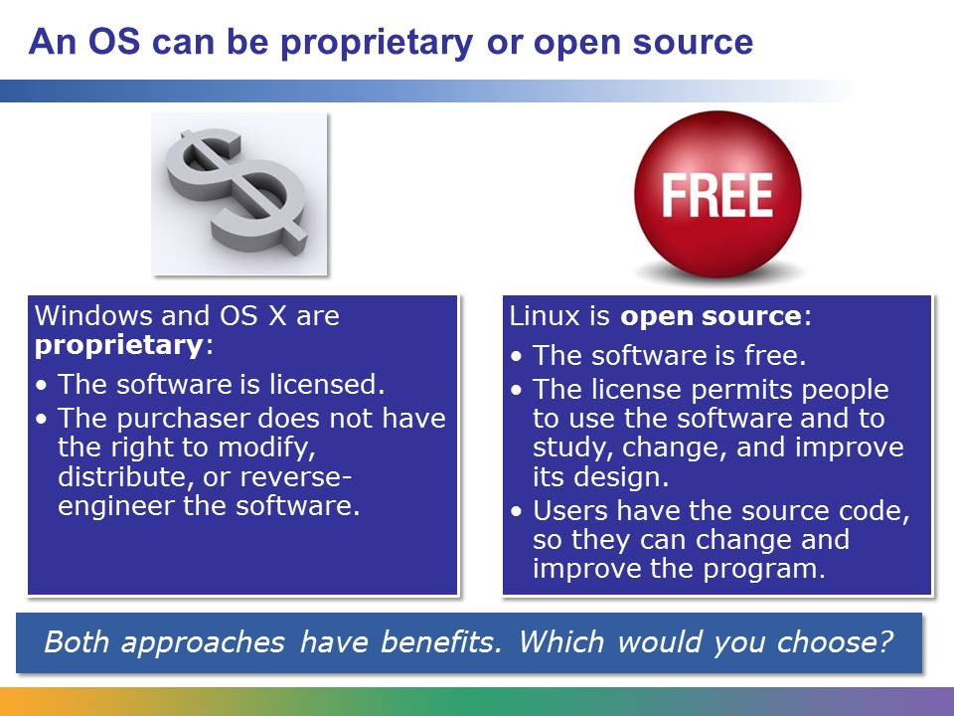

A proprietary OS has some advantages. It is developed by a single firm and is subject to strict testing, use, and development standards. Ideally, when you buy a software license for an operating system, you expect that the OS will work correctly right out of the box. A proprietary operating system is almost always installed on your computer when you buy the computer. If you run into trouble, the company will stand behind its product.

Also, most proprietary software, whether an OS or an application, comes with some level of support with the purchase price. Among other things, this entitles you to free upgrades when they become available. In the case of Windows, upgrades are released often, and your computer can automatically download and install them from the Internet with little or no user intervention.

Open source software also has advantages. One big advantage is that open source software is free. Even though there is not a company to stand behind open source software, there are often online forums and support groups that help users who need support. Open source software is also adaptable in ways proprietary software is not. If you want to add a feature, change the way something works, or otherwise alter Windows, you’re out of luck. An open source OS, however, encourages innovation. You are free to customize the software as you see fit. Users are encouraged to share their changes—as well as the source code for those changes. While open source software does not come with automatic support, the open source community is so large that solutions to problems such as security flaws are often released quickly.

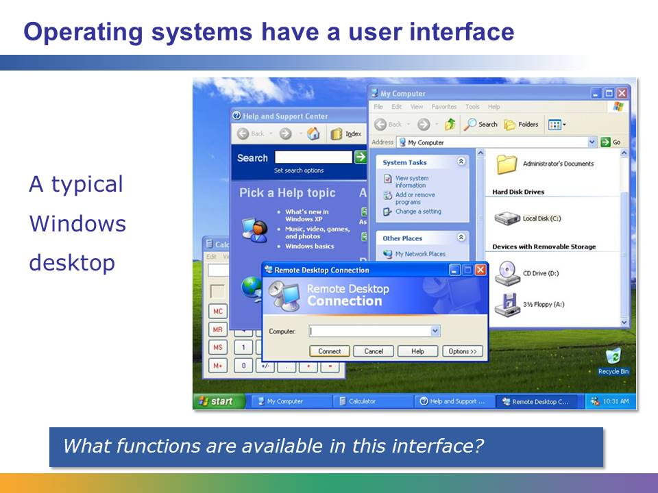

This is a typical Windows desktop. It has features like a toolbar at the bottom of the screen, folders and application aliases (shortcuts) for easy access to programs, files, and folders along the side of the screen, and other icons. You probably see something very much like this whenever you log on to your school computer.

Is this similar to what your Windows desktop looks like, or do you have a different version of Windows or perhaps a Mac?

This screenshot is from a guide compiled by Marcin Wichary and is used here with his permission. It can be accessed at <http://www.guidebookgallery.org/screenshots/winxppro>.

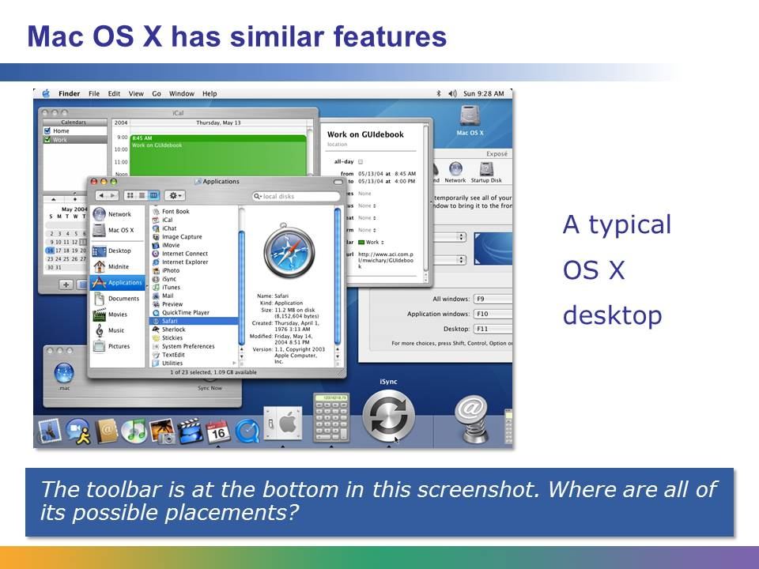

This is a typical Mac OS X desktop. It has features like a toolbar at the bottom of the screen, folders and application aliases (shortcuts) for easy access along the side of the screen, and other icons. Once you’ve learned how to use one OS, learning others is pretty simple.

This screenshot is from a guide compiled by Marcin Wichary and is used here with his permission. It can be accessed at <http://www.guidebookgallery.org/screenshots/macosx103>.

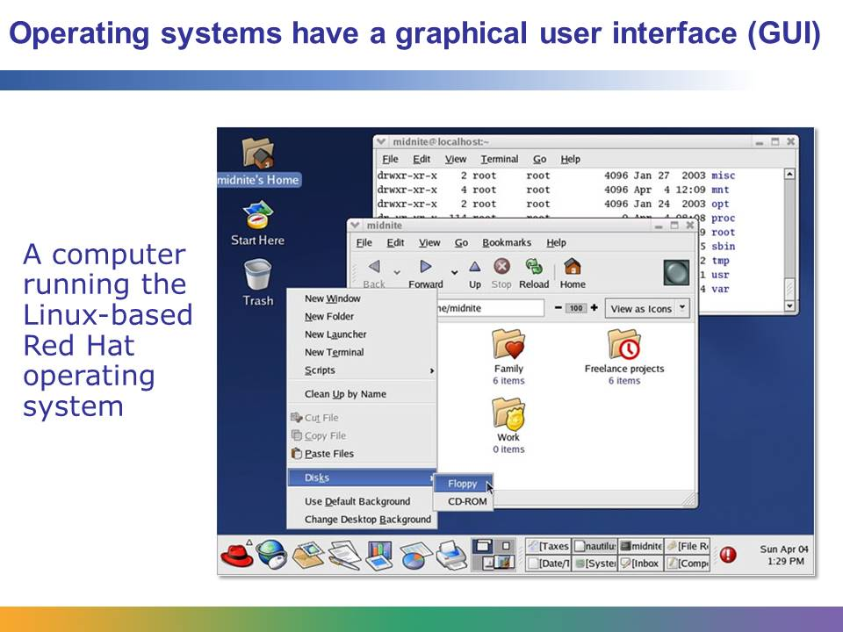

This screenshot shows a computer running the Red Hat Linux operating system. Notice how it is similar to the Windows desktop, but not identical. There is a toolbar along the bottom of the screen, but it is a series of icons and buttons.

This screenshot is from a guide compiled by Marcin Wichary and is used here with his permission. It can be accessed at <http://www.guidebookgallery.org/screenshots/gnome220redhat9>.

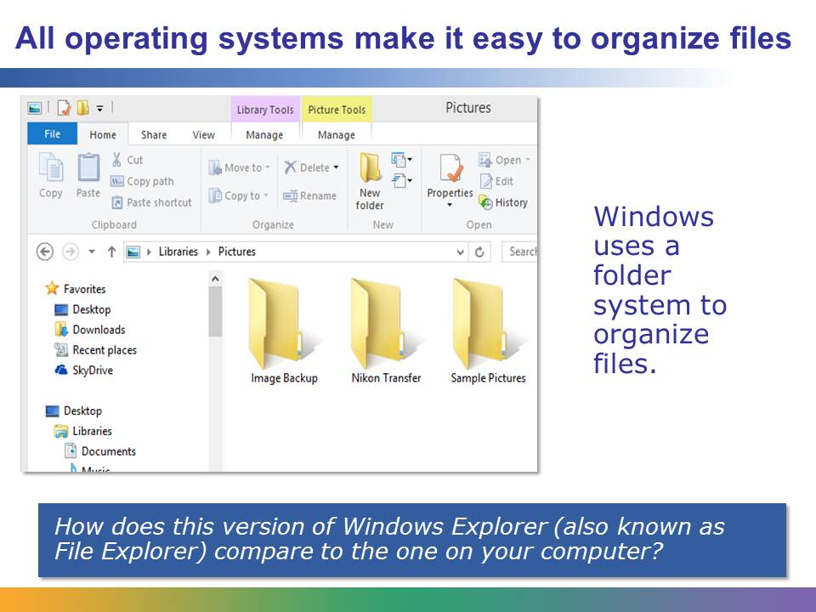

The file manager in Windows makes it easy to keep track of and organize files. In this screen, you can see file folders and icons representing internal and external storage devices. If you were to double-click one of these, you would see what was stored in it.

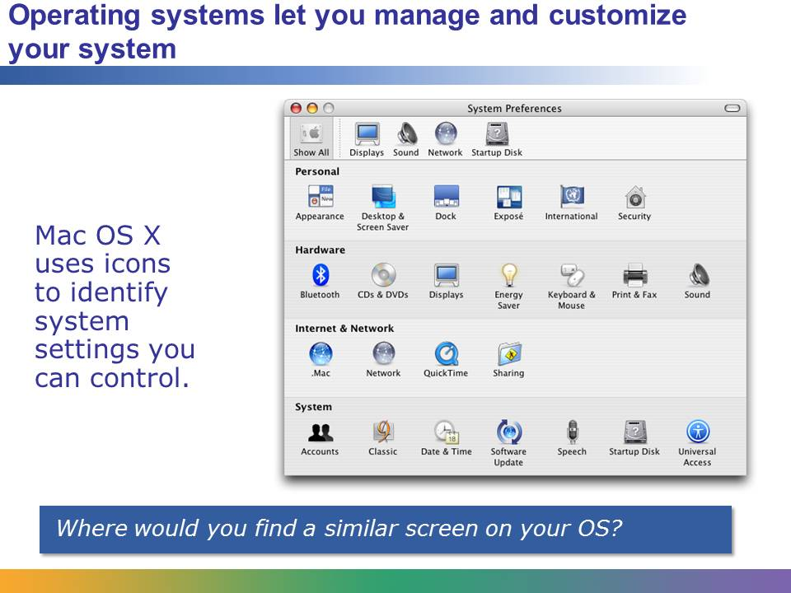

System Preferences in OS X makes it easy to customize the hardware and system settings. For Windows, the system settings are in the Control Panel.

This screenshot is from a guide compiled by Marcin Wichary and is used here with his permission. It can be accessed at <http://www.guidebookgallery.org/screenshots/>.

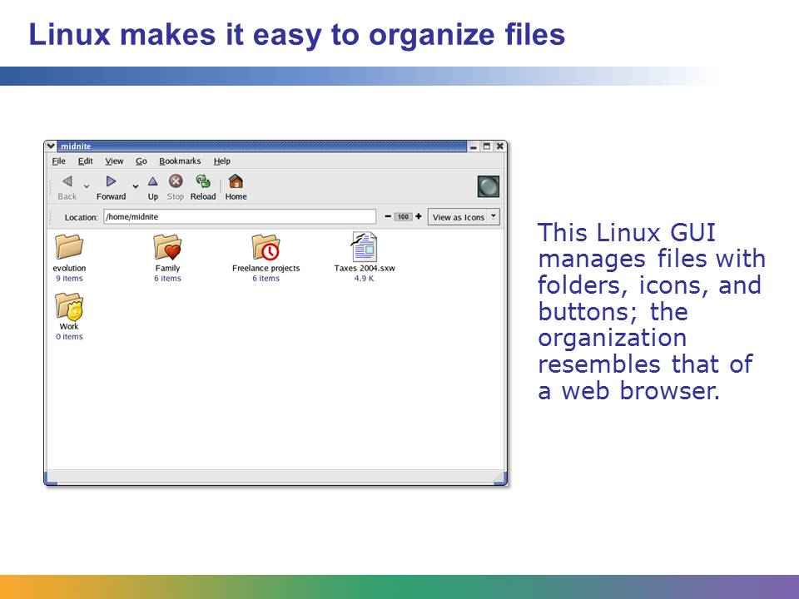

Linux also uses folders to help users manage their files (although folders are usually referred to as directories and subdirectories in Linux). This Red Hat Linux file manager is organized much like a web browser, with Back, Forward, and Reload buttons to help users navigate through file and folder levels.

This screenshot is from a guide compiled by Marcin Wichary and is used here with his permission. It can be accessed at <http://www.guidebookgallery.org/screenshots/gnome220redhat9>.

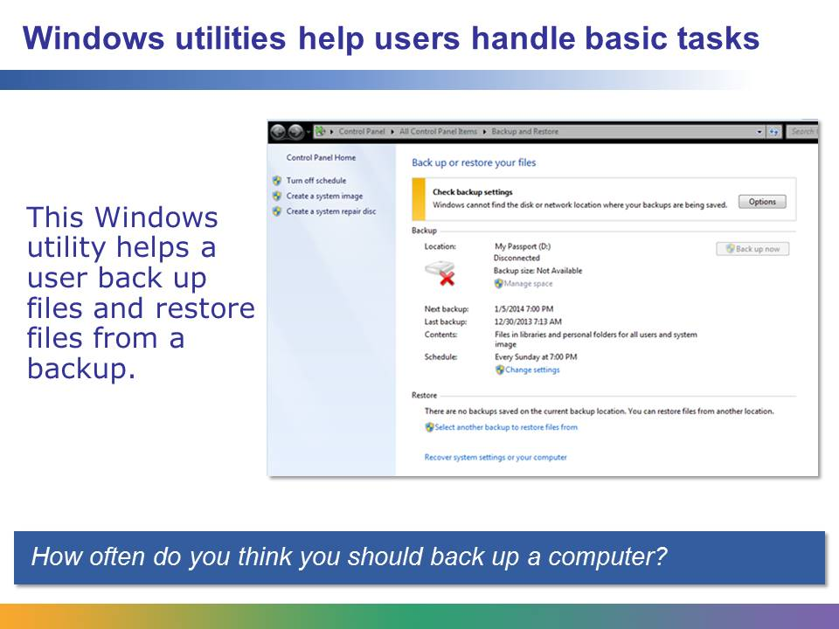

Operating systems feature programs called “utilities” that help users manage other programs. Any time you install, uninstall, back up, or otherwise work with a program that manages a software package, you are using a utility.

Windows 8.1 and Windows 10 allow file backup and recovery from the File History menu. You can create a complete system image (a copy of Windows along with all your programs, system settings, and files) and save it to an external drive (USB drive or DVDs).

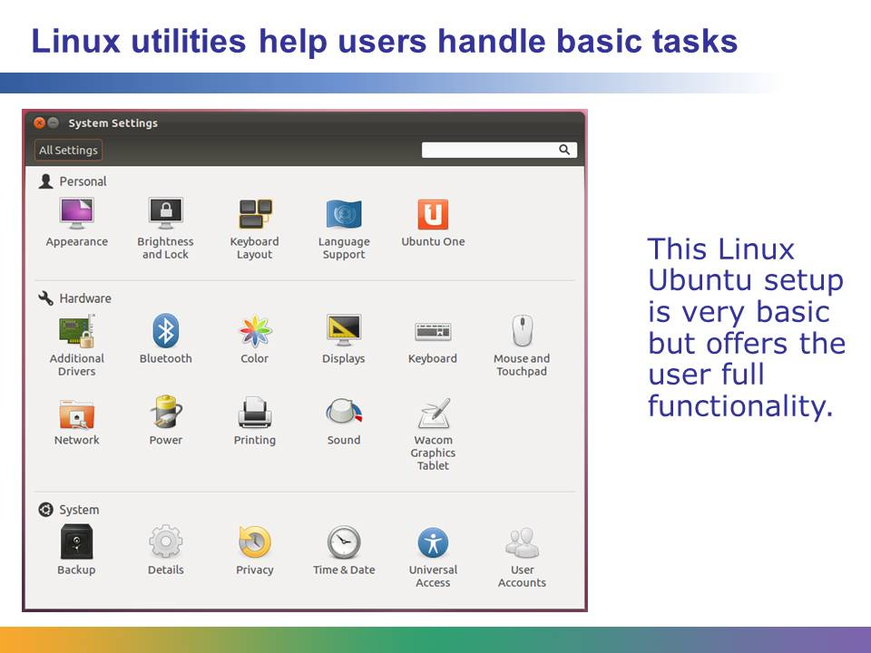

Users access this Ubuntu settings panel (also called a control panel) to manage the computer, including settings for default applications (which email or word processor to use, for example) and network connection settings.

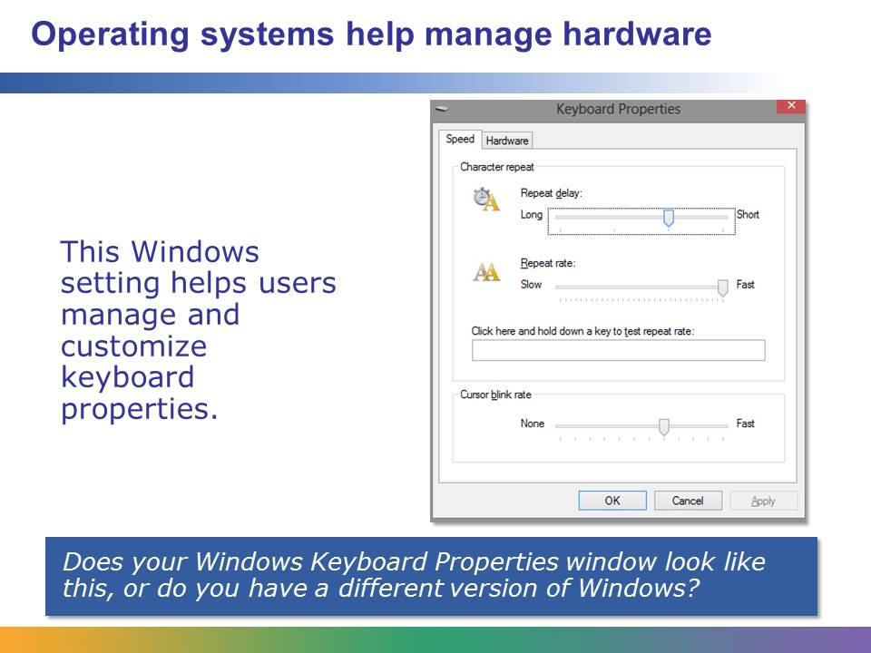

Managing hardware such as keyboards, mice, and monitors helps people customize their computer’s behavior and function. This Keyboard Properties window enables a user to choose preferences such as how quickly each key will repeat when held down and how quickly the cursor blinks. The Windows Control Panel provides access to these hardware settings.

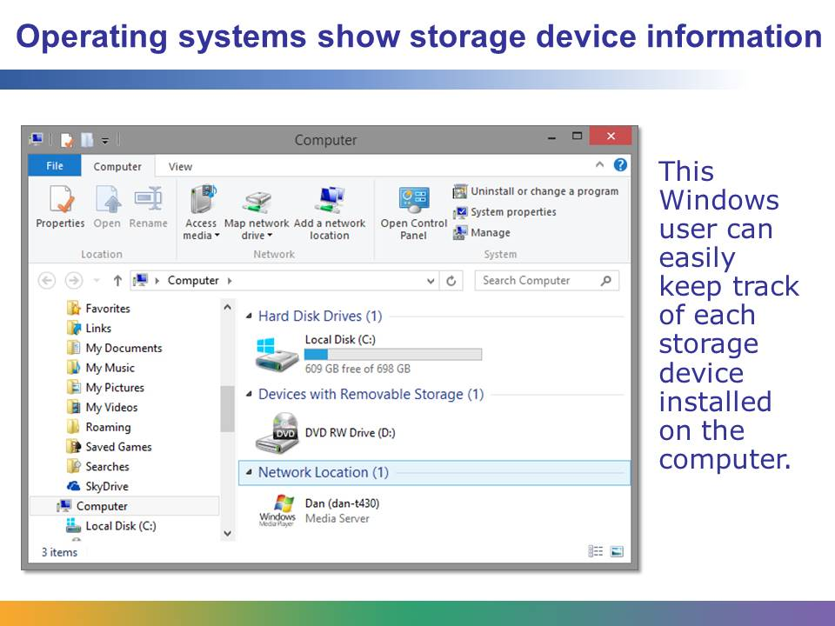

Operating systems help users manage their hardware, such as external storage devices, by showing each device on the screen with information about available disk space, path locations (is it the C: drive or the D: drive, for example), total disk size, and device name.

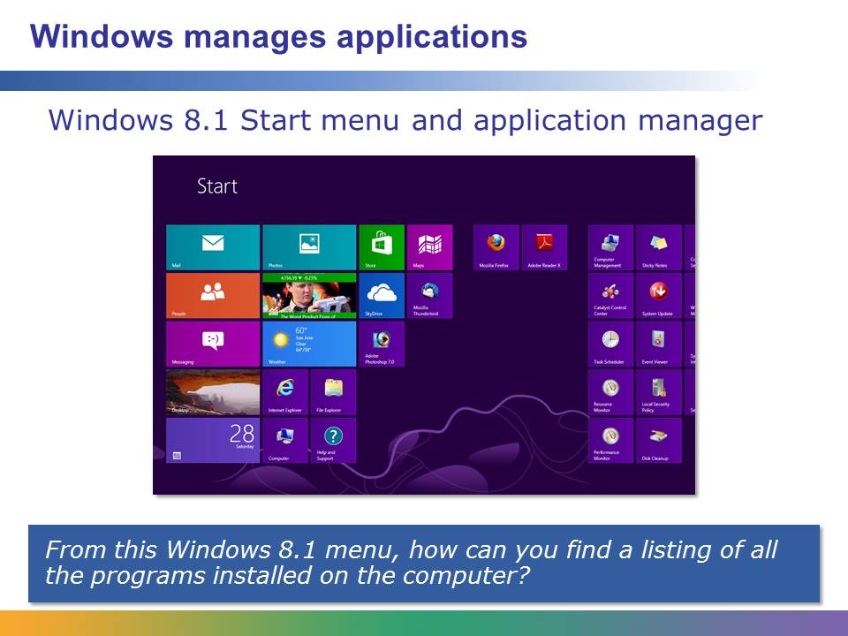

Application managers store data about each application in one place, making it easy for people to see which applications are installed on the computer.

For Windows 8.1, you can see all the applications by placing the cursor anywhere on the screen and right-clicking, and choosing All Apps in the lower-right portion of the screen. For earlier versions of Windows, click the Start button in the lower-left corner of the screen and select All Programs.

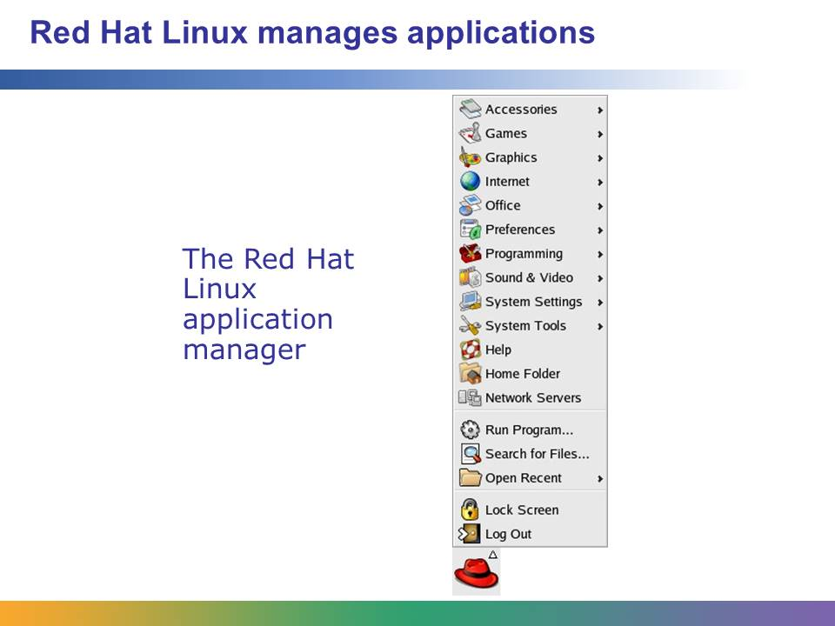

Linux has a series of hierarchical file folders to keep applications and data organized.

This screenshot is from a guide compiled by Marcin Wichary and is used here with his permission. It can be accessed at <http://www.guidebookgallery.org/screenshots/gnome220redhat9>.

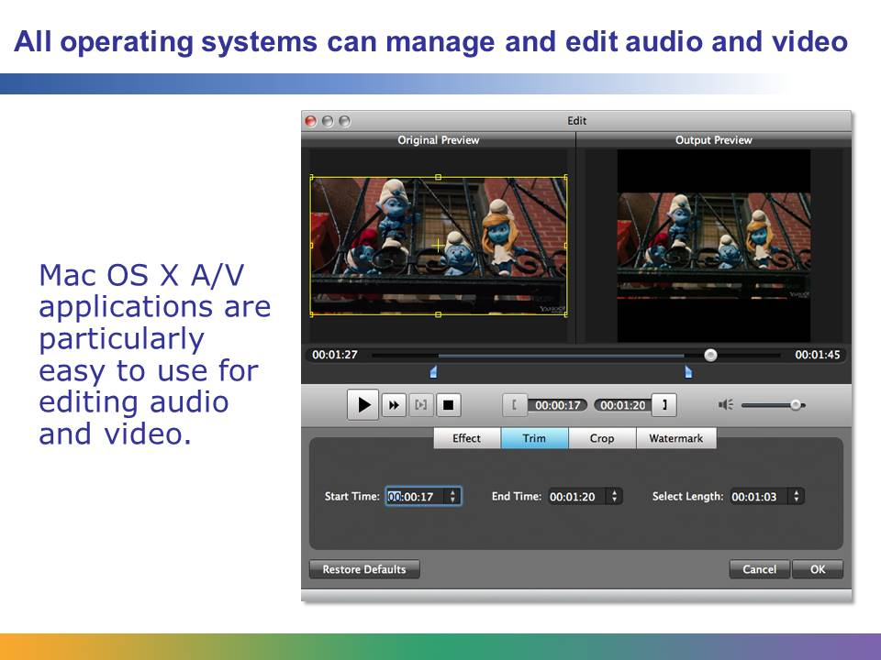

Creating and editing A/V information is a popular activity on modern computers. Fast quad-core processors are a must if you do a lot of A/V editing. Mac OS X is a good choice for an operating system because the A/V software being produced for this platform tends to be the best available. However, both Windows and Linux also have A/V software, and in some cases, the same software titles available for Mac OS X are also available for Windows and Linux.

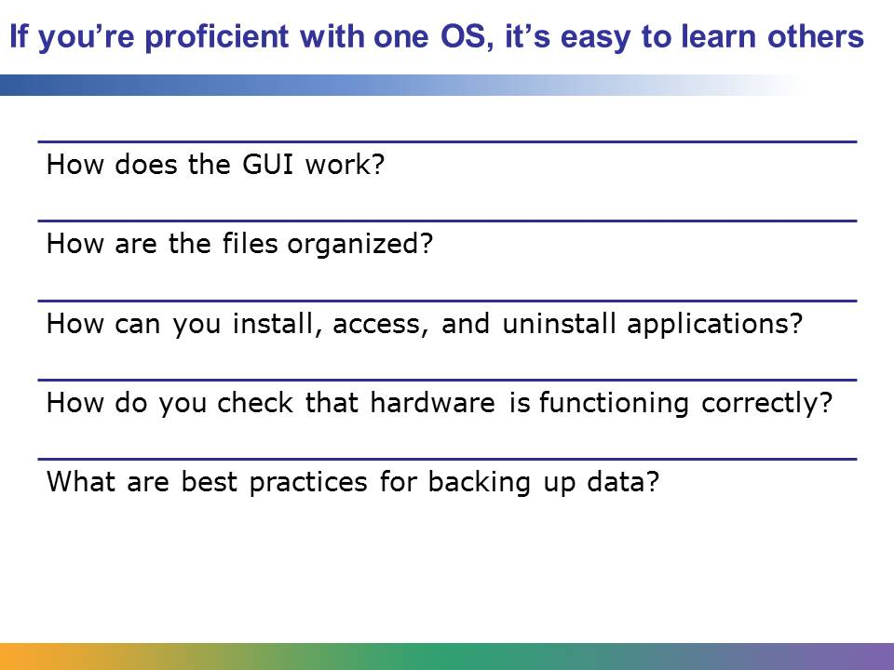

At different points in your education and career, you will be called on to use different operating systems. If you can answer the questions on this slide about the operating system you are using, it will be easy for you to move to another operating system, because you understand the basic concepts.

Student Resource 12.3

Venn Diagram: Operating Systems

*Directions: Think about what you have learned about the Linux, Mac OS X, and Microsoft Windows operating systems. How are they different? How are they similar? Use a Venn diagram to define and describe the similarities and differences. Look at the model below to get started. The left circle contains all the Windows-only features or traits you can think of, the right circle contains the Linux features, and the bottom circle contains the Mac OS X features. Any traits that the operating systems share go in the overlap areas. Draw your own diagram on chart paper and fill in the circles.*

**Linux**

**Windows**

Open source OS

**Shared traits**

Proprietary OS

**Mac OS X**

Student Resource 12.4a

Reading: Managing Files in Windows 7

Directions: All recent versions of Windows (Windows 7, Windows 8, Windows 10) have fairly similar ways of managing files, but their graphical user interfaces (GUIs) do not look exactly alike, and they do not work exactly alike. This reading refers to the Windows Explorer in Windows 7. Alternative versions of the reading, called “Managing Files in Windows 8.1” (Student Resource 12.4b) and “Managing Files in Windows 10” (Student Resource 12.4c), are also available. If you are using a different version of Windows Explorer, note anything that is different as you are reading.

How Do I Manage My Files?

Windows operating systems allow you to create, store, rename, edit, sort, and delete files such as text documents, spreadsheets, pictures, and music. It’s easy to manage your files with Windows Explorer in Windows 7. First, you need to create a folder, which is represented by an icon that looks just like a real manila folder. Then you can move your files into the folder.

Viewing Files on the Hard Drive

To view files already stored on a computer running Windows 7, click the Windows Explorer icon in the taskbar. It looks like a manila folder.



**The Windows Explorer icon in the Windows 7 taskbar (the tooltip “Windows Explorer” appears when the mouse cursor is held over the icon)**

You can also click the Start icon and then select Computer, or you can click the Start icon and select Documents or Pictures, depending on the type of files you are looking for. Alternatively, you can click Start icon > All Programs > Accessories > Windows Explorer. A shortcut way to open Windows Explorer is to press the Windows Logo key **** and the E key at the same time.

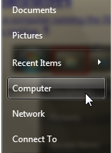

**One of the many ways to open Windows Explorer in Windows 7**

If you click the Start icon and select Computer, a window opens that shows your hard drives and the amount of free space remaining on each one, as well as any optical drives (DVD, CD, Blu-ray), and any USB thumb drives that are plugged in. Each device is represented by a unique identifier known as the drive letter. In a typical computer with one hard drive and one optical drive, the normal lettering would be C: for the hard drive and D: for the optical drive.

Double-click any of the drives to see the files and folders stored there.

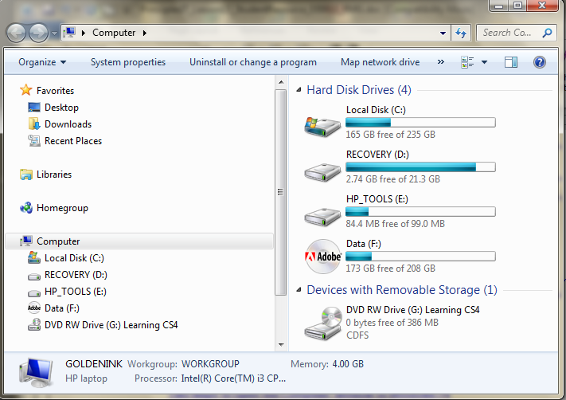

**The Computer window in Windows 7**

Creating a New Folder

If you want to save a document or a picture to your hard drive, you first need to decide where you want to store that file. It’s important to save your files in a place that makes sense to you, so that you can find them again when you need them. After you decide where you want to save your file, create a new folder with a name that you will remember.

To create a new folder, click New Folder in the toolbar at the top of the window. This feature is new to Windows 7.

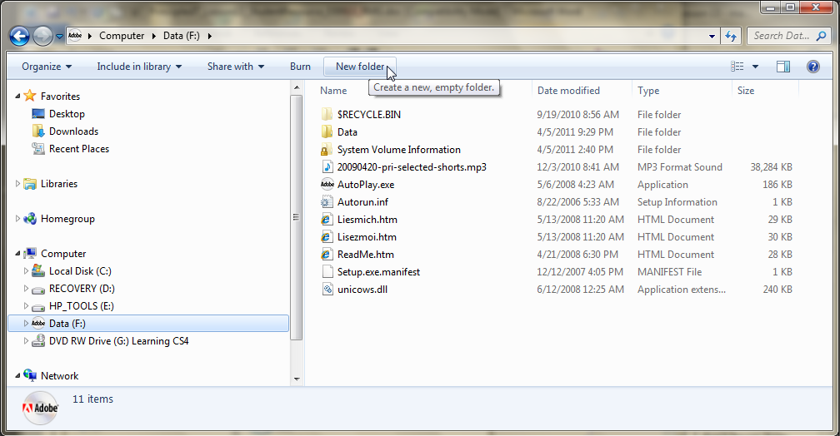

**Creating a new folder**

A new icon will appear in the list of folders and files in that partition, with a field where you can type in a new name for that folder. In this example, the new folder is named “MyResumes.”

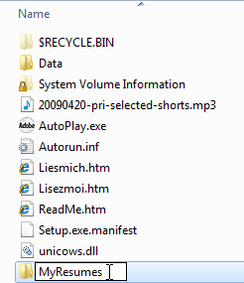

**Naming the new folder**

Your new folder is now ready to hold files.

Moving a File into a Folder

One way to move your files is to drag and drop them from the desktop into the folder. To do so, click the file you want to move and drag it to the destination folder and drop the file there. You can also drag files from one folder to another.

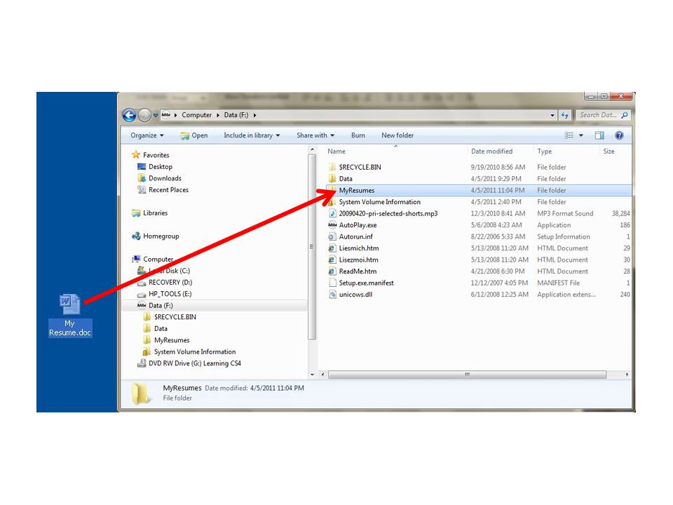

**Dragging a file to your MyResumes folder**

Windows 7 also lets you create what looks like a dual-pane Windows Explorer so that you can easily drag files from one folder to another. Try these four simple keystrokes:

* Windows Logo + E to open Windows Explorer
* Windows Logo + Left Arrow to snap Windows Explorer to the left side of your screen
* Windows Logo + E to open another Windows Explorer
* Windows Logo + Right Arrow to snap this Windows Explorer to the right side of your screen

Once you have the two windows open, you can easily copy files from one folder or drive to another.

Working with Files

When you right-click a file in Windows Explorer, a drop-down menu appears. From this menu, you can open, cut, copy, delete, or rename the file. You can also send the file to another person by fax or email, or you can compress it into a ZIP folder, which makes the file smaller and easier to send via email. And you can check the properties of a file by selecting Properties. This will show you the size of the file and when it was created, in addition to other details.

From this menu, you can also create a shortcut to the file. A shortcut is a link to a file; double-clicking the shortcut opens the file. Shortcuts help you keep access to files you use often in one place, such as your desktop or a library.

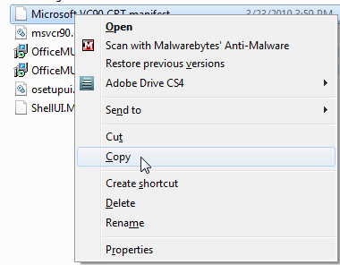

**This menu opens when you right-click a file name**

Using Libraries

Windows 7 introduced libraries, which are like folders, but they don’t actually store your files. A library holds files in one location for easy access even if they are stored in different places. For example, if you have music files in folders on your hard disk and on an external drive, you can use the Music library to access all your music files from one place.

Windows 7 gives you four default libraries: Documents, Music, Pictures, and Videos. You can add more libraries to help keep your files organized.

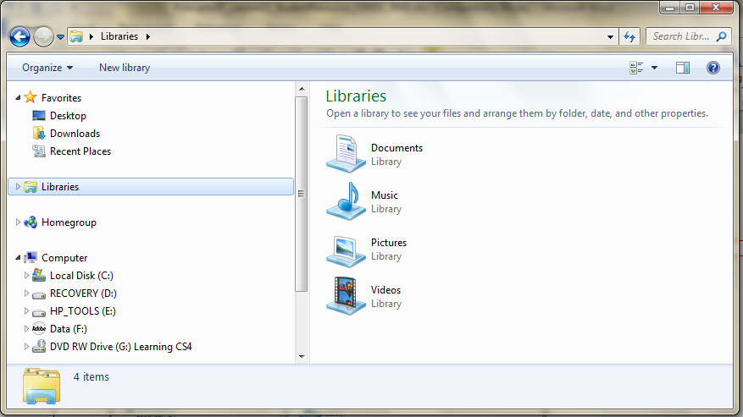

**The Libraries folder**

The Windows 7 Explorer Toolbar

The Windows 7 Explorer toolbar offers you many options. You can click the buttons in this toolbar to organize the contents of a folder and change the layout of the window. You can also include the folder in one of your libraries, or share it with certain people. If you click the E-mailbutton, Windows will generate an email with that folder as an attachment, ready to send. If you click the Burn button, Windows will ask you to put a writeable CD in your CD drive so that you can burn that file or folder to a CD.



**The Windows 7 Explorer toolbar**

Organizing Folders

You may have noticed that the navigation pane of Windows 7 doesn’t have a tree structure like that in previous versions of Windows. If you want easy access to certain folders from the navigation pane, you can drag the folder from the right pane to the navigation pane on the left, and you will then have a shortcut to that folder that stays in the navigation pane. The following screenshot shows a navigation pane where the student dragged a folder for each of his NAF classes into the navigation pane for quick access.

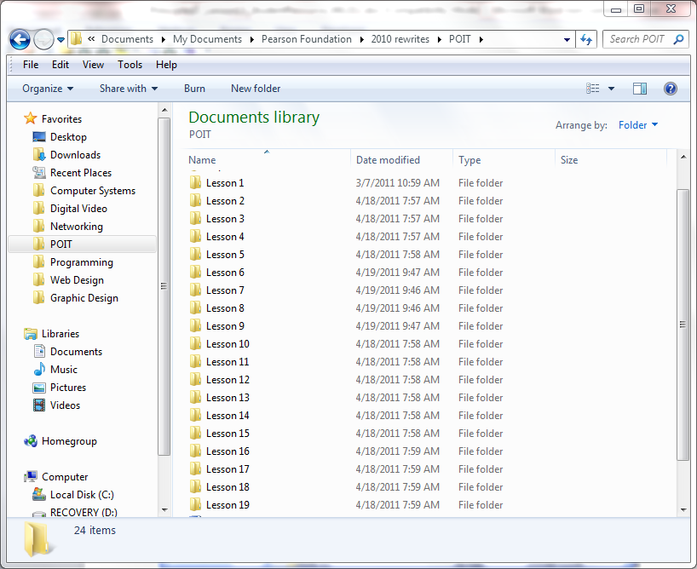

**Adding folder shortcuts to the navigation pane**

You can also click Organize in the toolbar and select Folder Options and Search Options to organize your folders. Under “Navigation pane,” select both “Show all folders” and “Automatically expand to the current folder” to display a tree structure in the navigation pane.

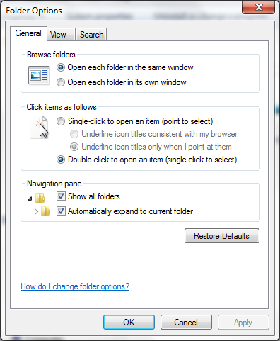

**The Folder Options window**

Sorting Files in Folders

Sometimes you may have so many subfolders or files in a folder that you’ll have to sort them to find the one you want. Often the most convenient way to sort Windows files is by the date they were last modified; that way, the latest file appears at the top of the list. You can also sort files by name, size, and type (such as document, picture, and so on) by clicking those words near the top of the right pane. To sort a file by date, click Date Modified in the file pane of the Windows Explorer screen. If you want to re-sort, click Date Modifiedagain, and the files will be sorted in the opposite order (with the oldest at the top). The default is to sort in ascending order by name.

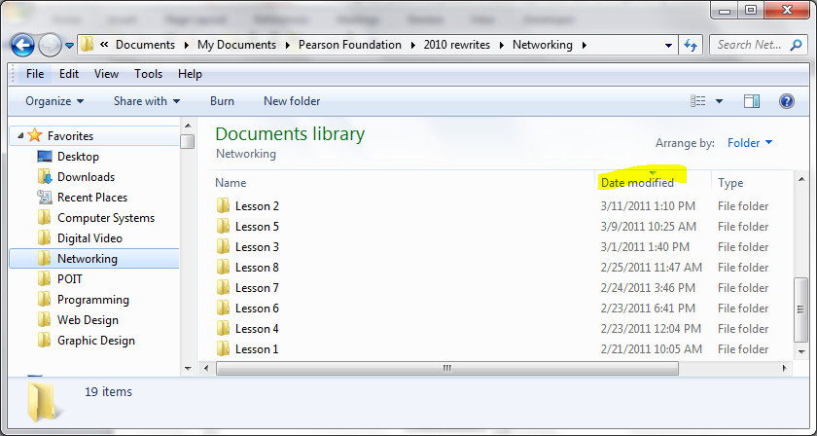

**Sorting your files by Date Modified**

Another way to find the file you are looking for is to use the Search box at the upper right of the Windows Explorer window. Select the folder you want to search and then type the word or phrase you are looking for. The window will display all the files that contain that word or phrase.

Changing the Way Files and Folders Appear

You can change the way files and folders appear in the window by clicking the “Change your view” button in the toolbar.

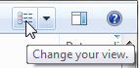

**The “Change your view” button**

You can choose to see more or less information about each file, and you can change the size of the icons that appear for each type of file. To do so, click the “Change your view” button. From here you can change the view to match the setting, which can be Extra Large, Large, Medium, or Small Icons, as well as List, Details, Tiles, or Content. Click the arrow to the right of the “Change your view” button to see what the setting is or to choose another one. You can also move the slider up or down to fine-tune the size of the file and folder icons. You can watch the icons get bigger and smaller as you move the slider.

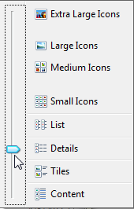

**Options available for how files and folders appear**

The Preview Pane button is on the right side of the toolbar. This button allows you to quickly and easily preview the contents of a file. You can also toggle the preview pane from the Organize > Layout menu.

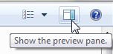

**The Preview Pane button**

Keep in mind that most files will have extensions to their name (such as *.txt* for a text file, *.html* for an HTML file, and *.docx* for a Microsoft Word document). These extensions are not usually displayed unless you have selected that you want extensions displayed from Explorer’s folder options.

Student Resource 12.4b

Reading: Managing Files in Windows 8.1

Managing files in Windows 8.1 is very similar to managing files in Windows 7, but some of the windows that you see on the screen look different. This reading shows what Windows 8.1 looks like when it is in Desktop mode, rather than Metro or mosaic tile mode.

How Do I Manage My Files?

Windows operating systems allow you to create, store, rename, edit, sort, and delete files such as text documents, spreadsheets, pictures, and music. It’s easy to manage your files with *File Explorer* in Windows 8.1. (File Explorer is the new name for what previous versions called Windows Explorer.) First, you need to create a folder, which is represented by an icon that looks just like a real manila folder. Then you can move your files into the folder.

Viewing Files on the Hard Drive

To view files already stored on a computer running Windows 8.1 in Desktop mode, click the File Explorer icon in the taskbar. It looks like a manila folder. The tooltip “File Explorer” appears when the mouse cursor is held over the icon.

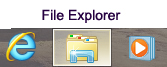

**The File Explorer icon in the Windows 8.1 taskbar**

You can also click the Windows Logo key **** to open the Windows 8.1 Start menu, and then select the File Explorer tile. You can arrange the tiles by dragging them to your favored location, so your Start screen probably looks different from the screenshot shown here.

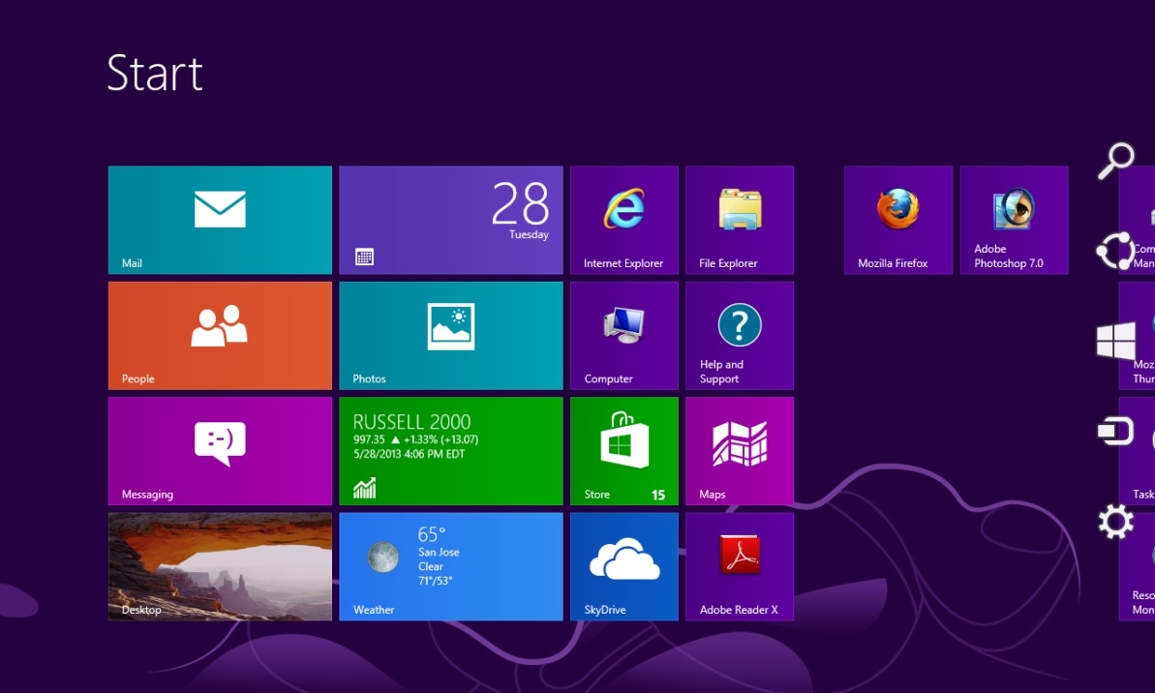

Desktop Mode

Computer

File Explorer

**Opening Windows 8.1 File Explorer from the Start menu in Metro mode**

If you click the Computer tile in the Start menu, a window opens that shows your hard drives and the amount of free space remaining on each one, as well as any optical drives (DVD, CD, Blu-ray), and any USB thumb drives that are plugged in. Each device is represented by a unique identifier known as the drive letter. In a typical computer with one hard drive and one optical drive, the normal lettering would be C: for the hard drive and D: for the optical drive. Double-click any of the drives to see the files and folders stored there.

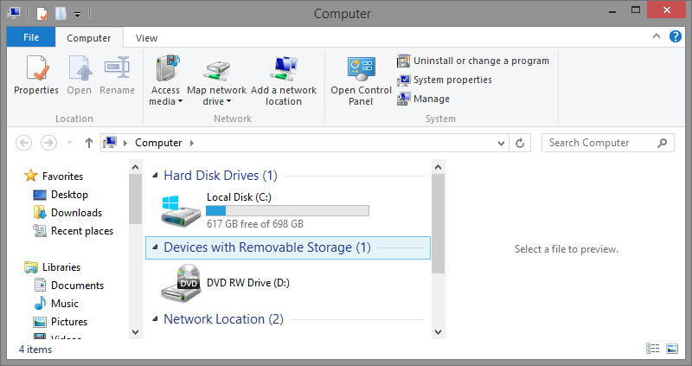

**The Computer window in Windows 8**

Ribbons in Windows 8.1

Windows 8 uses a different layout for creating, viewing, and managing files and folders called *ribbons*. Ribbons replace the Windows Explorer toolbar in previous versions of Windows.When you open File Explorer, you see several tabs at the top of the window, and below the tabs, there is a ribbon with several options for that tab. Open File Explorer and click each of the tabs to view the features of that ribbon and become familiar with its features and options. The screenshots here show the four main ribbons (if you have video and graphics file types, you will see additional ribbons).

****

**Use the Manage ribbon to manage your libraries and set save locations**

****

**Use the Home ribbon to add new folders, delete folders, or change a folder’s properties**

****

**Use the Share ribbon to share with other people on your network or to burn a CD**

****

**Use the View ribbon to specify how you want to show folders (icons or details, sort by name or date)**

Creating a New Folder

To create a new folder, click New Folder in the Home ribbon at the top of the window.

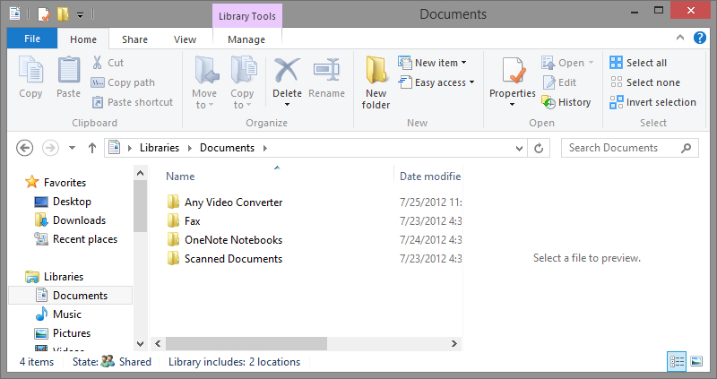

New Folder icon

**Creating a new folder**

A new icon will appear in the list of folders and files in that partition, with a field where you can type in a new name for that folder. For example, you can type “MyResumes” to create a folder with that name. Your new folder is now ready to hold files.

\

**Naming the new folder**

Moving a File into a Folder

One way to move your files is to drag and drop them from the desktop into the folder. To do so, click the file you want to move and drag it to the destination folder and drop the file there. You can also drag files from one folder to another.



**Dragging a file to your MyResumes folder**

You can also create a dual-pane File Explorer so that you can easily drag files from one folder to another. Try these four simple keystrokes (hold down the Windows Logo key  and then press the second key shown):

* + E to open the Computer View, then click the hard drive icon
*  + Left Arrow to snap File Explorer to the left side of your screen
*  + E to open another File Explorer window using the Computer View
*  + Right Arrow to snap this File Explorer to the right side of your screen

Once you have the two windows open, you can easily copy files from one folder or drive to another by clicking and dragging.

Working with Files

When you right-click a file in File Explorer, a drop-down menu appears. From this menu, you can open, cut, copy, delete, or rename the file. You can also send the file to another person by fax or email, or you can compress it into a ZIP folder, which makes the file smaller and easier to send via email. And you can check the properties of a file by selecting Properties. This will show you the size of the file and when it was created, in addition to other details.

From this menu, you can also create a shortcut to the file. A shortcut is a link to a file; double-clicking the shortcut opens the file. Shortcuts help you keep access to files you use often in one place, such as your desktop or a library.



**This menu opens when you right-click a file name**

Using Libraries

Like Windows 7, Windows 8.1 has libraries, which are like folders, but they don’t actually store your files. A library holds files in one location for easy access even if they are stored in different places. For example, if you have music files in folders on your hard disk and on an external drive, you can use the Music library to access all your music files from one place.

Windows 8.1 gives you four default libraries: Documents, Music, Pictures, and Videos. You can add more libraries to help keep your files organized.

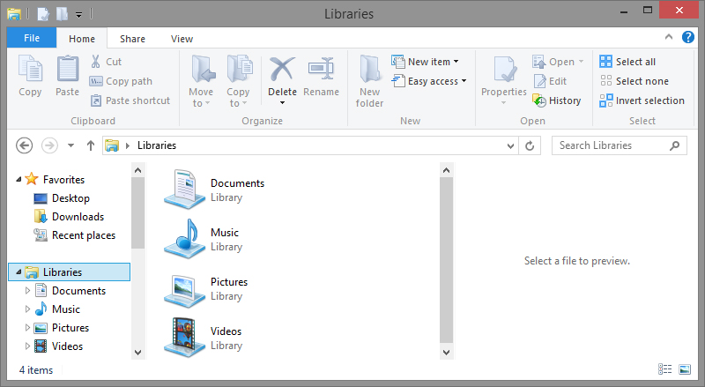

**The Libraries folder in Windows 8.1**

Organizing Folders

You may have noticed that the navigation pane of Windows 8.1 doesn’t have a tree structure. If you want easy access to certain folders from the navigation pane, you can drag the folder from the right pane to the navigation pane on the left, and you will then have a shortcut to that folder that stays in the navigation pane. The following screenshot shows the navigation pane options in the View ribbon.

|  |  |
| --- | --- |
|  | The “Expand to open folder” option shows the entire tree structure to the currently open file. Many other options are available in the View ribbon; you can sort files and folders, show size and date modified, and show small, medium, and large icons of the files and folders. |

Sorting Files in Folders

In Windows 8.1, you can use the View ribbon to sort files within folders. Often the most convenient way to sort Windows files is by the date they were last modified; that way, the most recent file appears at the top of the list. You can also sort files by name, size, and type (such as document, picture, and so on) by selecting those “Sort by” options in the View ribbon. To sort a file by date, click Sort By > Date Modified. If you want to re-sort, click Sort By > Date Modifiedagain, and the files will be sorted in the opposite order (with the oldest at the top).

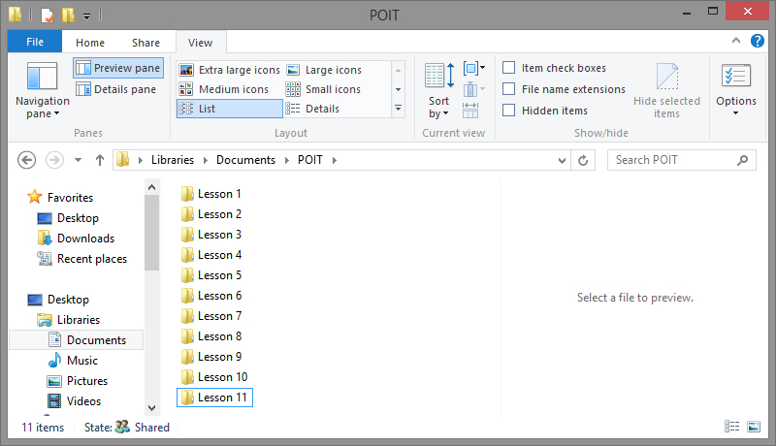

Search for files

Sorting and viewing files and folders

**File and folder sorting options in Windows 8.1 using the View ribbon**

Another way to find the file you are looking for is to use the Search box at the upper right of the File Explorer window. Select the folder you want to search and then type the word or phrase you are looking for. The window will display all the files that contain that word or phrase in either the file name or in the content of the file.

You can choose to see more or less information about each file, and you can change the size of the icons that appear for each type of file. From the Layout group in the View ribbon, you can change the view to show extra-large, large, medium, or small icons, or you can choose List, Details, Tiles, or Content. Click each icon within the Layout group to see what the setting does.

Student Resource 12.4c

Reading: Managing Files in Windows 10

Managing files in Windows 10 is very similar to managing files in Windows 7 and 8.1, but some of the windows that you see on the screen look different.

How Do I Manage My Files?

Windows operating systems allow you to create, store, rename, edit, sort, and delete files such as text documents, spreadsheets, pictures, and music. It’s easy to manage your files with *File Explorer* in Windows 10. (File Explorer is the new name for what previous versions called Windows Explorer.) First, you need to create a folder, which is represented by an icon that looks just like a real manila folder. Then you can move your files into the folder.

Viewing Files on the Hard Drive

To view files already stored on a computer running Windows 10 in Desktop mode, click the File Explorer icon in the taskbar. It looks like a manila folder. The tooltip “File Explorer” appears when the mouse cursor is held over the icon.

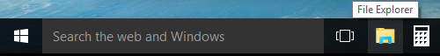

**The File Explorer icon in the Windows 10 taskbar**

You can also click the Windows Logo key **** to open the Windows 10 Start menu, and then select File Explorer.

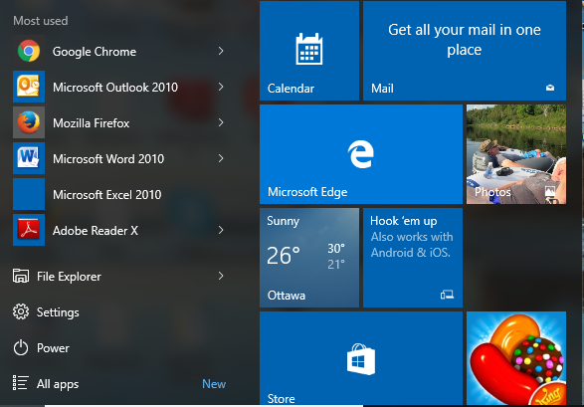

File Explorer

**Opening the Windows 10 Start menu**

If you click the This PC menu in File Explorer, a window opens that shows your hard drives and the amount of free space remaining on each one, as well as any optical drives (DVD, CD, Blu-ray), and any USB thumb drives that are plugged in. Each device is represented by a unique identifier known as the drive letter. In a typical computer with one hard drive and one optical drive, the normal lettering would be C: for the hard drive and D: for the optical drive. Double-click any of the drives to see the files and folders stored there.

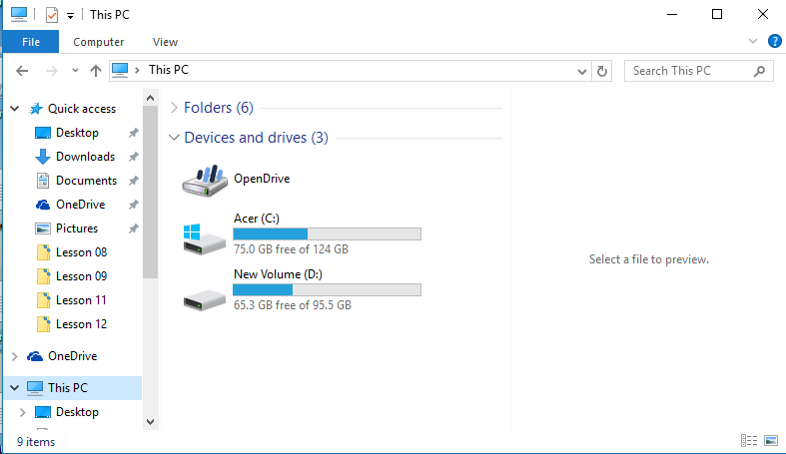

**The File Explorer window in Windows 10**

Ribbons in Windows 10

Windows 10 uses a different layout feature for creating, viewing, and managing files and folders called ribbons. Ribbons replace the Windows Explorer toolbar in previous versions of Windows.When you open File Explorer, you see several tabs at the top of the window, and below the tabs, there is a “ribbon” with several options for that tab. Open File Explorer and click each of the tabs to view the features of that ribbon and become familiar with its features and options. The screenshots here show the four main ribbons in File Explorer (if you have video and graphics file types, you will see additional ribbons).

**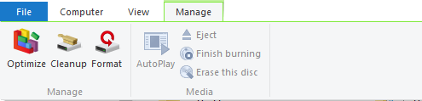**

Use the Manage ribbon to manage your libraries and set save locations.

**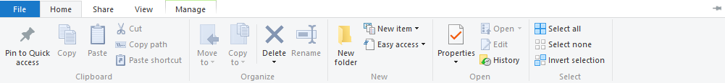**

Use the Home ribbon to add new folders, delete folders, or change a folder’s properties.

**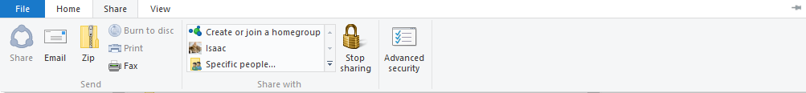**

Use the Share ribbon to share with other people on your network or to burn a CD.

**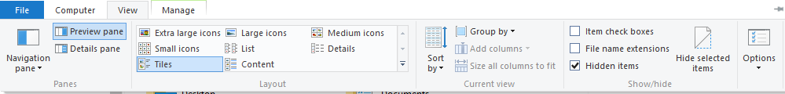**

Use the View ribbon to specify how you want to show folders (icons or details; sort by name or date).

Creating a New Folder

To create a new folder, click New Folder in the Home ribbon at the top of the window.

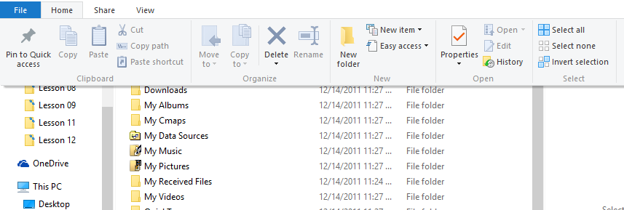

New Folder icon

**Creating a new folder**

A new icon will appear in the list of folders and files in that partition, with a field where you can type in a new name for that folder. For example, you can type “MyResumes” to create a folder with that name. Your new folder is now ready to hold files.

\

**Naming the new folder**

Moving a File into a Folder

One way to move your files is to drag and drop them from the desktop into the folder. To do so, click the file you want to move and drag it to the destination folder and drop the file there. You can also drag files from one folder to another.

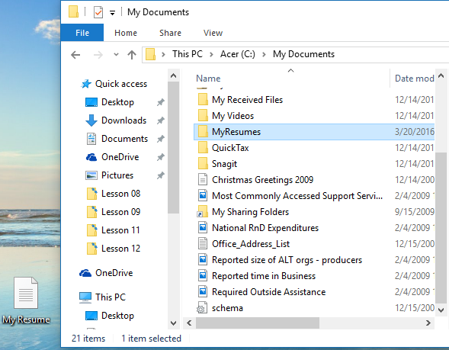

**Dragging a file to your MyResumes folder**

You can also create a dual-pane File Explorer so that you can easily drag files from one folder to another. Try these four simple keystrokes (hold down the Windows Logo key **** and then press the second key shown):

*  + E to open the Computer view; then click the hard drive icon
*  + Left Arrow to snap File Explorer to the left side of your screen
*  + E to open another File Explorer window showing the Computer view
*  + Right Arrow to snap this File Explorer to the right side of your screen

Once you have the two windows open, you can easily copy files from one folder or drive to another by clicking and dragging.

Working with Files

When you right-click a file in File Explorer, a drop-down menu appears. From this menu, you can open, cut, copy, delete, or rename the file. You can also send the file to another person by fax or email, or you can compress it into a ZIP folder, which makes the file smaller and easier to send via email. And you can check the properties of a file by selecting Properties. This will show you the size of the file and when it was created, in addition to other details.

From this menu, you can also create a shortcut to the file. A shortcut is a link to a file; double-clicking the shortcut opens the file. Shortcuts help you keep access to files you use often in one place, such as your desktop or a library.



**This menu opens when you right-click a file name**

Using Libraries

Like Windows 7 and 8.1, Windows 10 has libraries, which are like folders, but they don’t actually store your files. A library holds files in one location for easy access even if they are stored in different places. For example, if you have music files in folders on your hard disk and on an external drive, you can use the Music library to access all your music files from one place.

Windows 10 gives you four default libraries: Documents, Music, Pictures, and Videos. You can add more libraries to help keep your files organized.

The Libraries navigation is not turned on automatically in Windows 10. To turn on Libraries navigation:

1. Open File Explorer.
2. Instead of Home, go to This PC. (Your default libraries appear here.)
3. In the left pane, right-click the empty space to open the context menu.
4. Check the Libraries item.

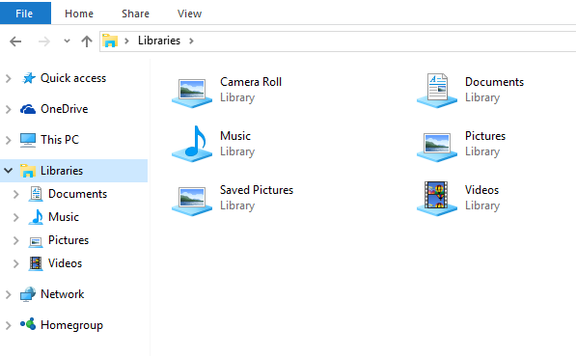

**The Libraries folder in Windows 10**

Organizing Folders

You may have noticed that the navigation pane of Windows 10 doesn’t have a tree structure. If you want easy access to certain folders from the navigation pane, you can drag the folder from the right pane to the navigation pane on the left, and you will then have a shortcut to that folder that stays in the navigation pane. The following screenshot shows the navigation pane options in the View ribbon.

|  |  |
| --- | --- |
|  | The “Expand to open folder” option shows the entire tree structure to the currently open file. Many other options are available in the View ribbon; you can sort files and folders, show size and date modified, and show small, medium, and large icons of the files and folders. |

Sorting Files in Folders

In Windows 10, you can use the View ribbon to sort files within folders. Often the most convenient way to sort Windows files is by the date they were last modified; that way, the most recent file appears at the top of the list. You can also sort files by name, size, and type (such as document, picture, and so on) by selecting those “Sort by” options in the View ribbon. To sort a file by date, click Sort By > Date Modified. If you want to re-sort, click Sort By > Date Modifiedagain, and the files will be sorted in the opposite order (with the oldest at the top).

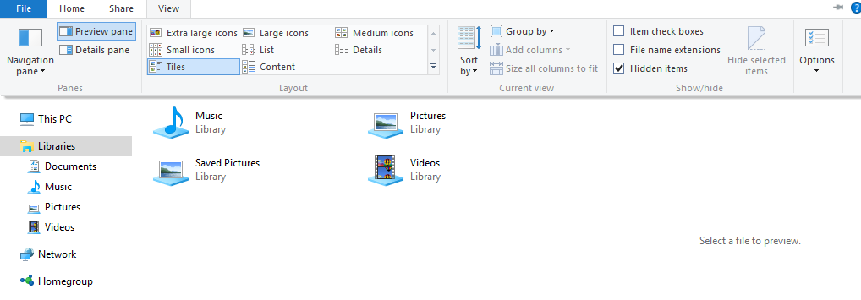

Sorting and viewing files and folders

**File and folder sorting options in Windows 10 using the View ribbon**

Another way to find the file you are looking for is to use the Search box at the upper right of the File Explorer window. Select the folder you want to search and then type the word or phrase you are looking for. The window will display all the files that contain that word or phrase in either the file name or in the content of the file.

You can choose to see more or less information about each file, and you can change the size of the icons that appear for each type of file. From the Layout group in the View ribbon, you can change the view to show extra-large, large, medium, or small icons, or you can choose List, Details, Tiles, or Content. Click each icon within the Layout group to see what the setting does.

Student Resource 12.5

Project Planner Page 7:   
Planning a Dream Personal Technology System

Student Names:\_\_\_\_\_\_\_\_\_\_\_\_\_\_\_\_\_\_\_\_\_\_\_\_\_\_\_\_\_\_\_\_\_\_\_\_\_\_\_\_\_\_\_\_\_\_\_\_\_\_\_\_\_\_\_\_\_\_\_\_\_

Directions: This is the seventh and final page of the project planner you’ll use to help plan your group’s personal technology system. Answer the questions below to identify and plan your computer’s operating system. Don’t forget to think about your whole system’s stated purpose when you are making this choice. Remember that you should have kept track of all of your project planner pages for the entire course. Your group will collect and submit all of these resources at the end of the project.

When your group has completed this planning sheet, add the information to the culminating project report you began in Lesson 7. Be sure that you have kept that report up-to-date—including adding a line to your project planning summary table!

What this system will be used for:

Which operating system will you install on your group’s computer or laptop? Why have you chosen this OS?

Student Resource 12.6

Assignment:   
Finalizing Your Project Planning Report

Congratulations! You have completed the final project planning page for your culminating project. The information your group has gathered will be invaluable when you make your final decisions about the hardware and software you will purchase to create your dream personal technology system.

This is your opportunity to make sure the project planning report you began in Lesson 7 is complete and contains all of the planning information you have gathered for your project. Take some time to review your project planning report, complete any information that is missing, and update any information that may have changed as you’ve learned more about personal technology hardware and software. You don’t have to have final answers about the exact parts you will purchase, but you should have a good idea of what your system will look like, and all of your information should be compiled in a report that is complete and professional.

Read the assessment criteria listed below before you begin finalizing your report.

Make sure your assignment meets or exceeds the following assessment criteria:

* All required pages of the project planner are complete and provide information that will be useful in making final decisions about the dream system’s hardware, peripherals, productivity application software, graphics and multimedia software, network hardware, Internet access, and operating system.
* Answers to the “why” questions in the project planner are coherent and show an understanding of basic computer hardware and software requirements.
* The project planning summary table provides a clear summary of the most attractive choices for each facet of the personal technology system.
* The project planning report is well formatted and makes good use of the template. All pages are neat and correctly formatted and use proper spelling and grammar.